Smartphone Addiction, Mental Health, Economy, and Security

SIT325 Task 10.2HD – High Distinction Research Activity

Ocean

S223503101

Contents

Abstract 2

Section I: Introduction 2

Section II: Problem with Evidence 3

Prevalence in Australia 3

Mental Health Effects 4

Economic Costs 5

Security and Privacy Risks 6

Section III: Literature Review (6 recent sources) 6

1) Black Dog Institute (2024) – Australian teens, screens, and mental health 6

2) Kabadayi et al. (2024) – Adolescents’ smartphone addiction & mental health 7

3) Marshall et al. (2025) – Australian children/teens: overuse and social development 7

4) Allcott, Gentzkow, & Song (2022) – Economic view of digital addiction 7

5) Upshaw et al. (2022) – Notifications degrade attention and accuracy 7

6) Zhu et al. (2025) – Addiction, negative emotions, and life satisfaction 7

Section IV: Gaps, Observations, and Recommendations 8

Gaps (what the evidence still misses) 8

Recommendations (multi-level, practical) 8

Section V: Conclusion 9

References 10

AI Acknowledgement Statement (for your SIT325 submission) 11

## Abstract

Smartphones have changed how young Australians live, learn, and connect. They provide fast access to information, social support, and entertainment, but heavy and uncontrolled use can lead to harm. This report examines *smartphone addiction* (also called *problematic smartphone use*) with a focus on teenagers, while comparing patterns across other age groups. It brings together recent studies and Australian evidence to answer a practical question: **How does smartphone addiction affect mental health, the economy, and security—and what should Australia do about it?**

The findings are clear on several fronts. First, mental health: excessive use is linked with poor sleep, stress, anxiety, depression, and lower life satisfaction. Teenagers are especially vulnerable because of late-night use, social comparison on apps, and cyberbullying pressures. Second, economy: mobile technology adds major value to Australia, yet distraction, presenteeism, and mental-health-related productivity loss likely reduce some of that benefit. Third, security: teens often keep default settings, overshare, and click risky links, which raises the chance of scams, identity theft, and data leaks. Evidence is drawn from six peer-reviewed articles and national reports. Gaps remain, especially in measuring the direct *dollar cost* of addiction in Australia and in evaluating which long-term interventions truly work for teens.

This report recommends practical steps at multiple levels: **schools** (digital wellbeing lessons and cyber-safety basics), **families** (clear boundaries and role-modeling), **health services** (counselling that includes digital habits), **technology companies** (less addictive design, more safety defaults), and **government** (policy guidance and public awareness). The goal is not to remove smartphones from teenage life, but to **rebalance use** so that benefits remain and harms are reduced.

## Section I: Introduction

Smartphones are one of the fastest-adopted technologies ever. Global users now exceed 6.5 billion. In Australia, ownership is among the highest in the world—close to nine in ten people have a smartphone. For teenagers, phones are central to social life, learning, creativity, and identity. Apps for messaging, videos, music, and gaming encourage constant engagement, and design choices like “likes,” streaks, push notifications, and endless scroll make it easy to keep checking.

*Smartphone addiction* is not a formal clinical diagnosis, but the term is widely used in research to describe patterns of use that are hard to control and that cause harm. These patterns look similar to behavioural addictions: cravings, loss of control, withdrawal-like discomfort when separated from the device, and continued use despite negative consequences. Teens are at greater risk than adults for two reasons: (1) **developmental factors**—areas of the brain tied to self-control and reward sensitivity are still maturing; and (2) **social drivers**—peer norms and online identity make phones feel “essential,” making limits harder to keep.

Why does this matter beyond personal habit? First, **mental health**: research links heavy use with sleep disruption, anxious mood, depressive symptoms, and lower well-being. Second, **economy**: while mobile technology contributes heavily to national value, phone-driven distraction at work and school can lower performance, and mental-health burdens increase costs. Third, **security**: unsafe settings, oversharing, and impulsive clicks expose teens to scams, phishing, and data leaks. Together, these impacts make problematic use a public concern that touches health, education, productivity, and cyber-safety.

This report examines the issue from three angles—mental health, economic impacts, and security risks—with a focus on Australian teenagers. It uses recent Australian data and six peer-reviewed or professional reports to explain the problem, review what researchers have tried, identify gaps, and propose practical recommendations for **schools, families, health services, technology firms, and government**.

## Section II: Problem with Evidence

### Prevalence in Australia

Smartphone use is widespread. A recent Australian study reported **~88% ownership** overall and found **~24.4% “high-severe” users** among adults aged 18–59 (indicating problematic patterns) (Khan et al., 2023: [https://link.springer.com/article/10.1007/s10916-023-02005-3](https://link.springer.com/article/10.1007/s10916-023-02005-3?utm_source=chatgpt.com)). Among teenagers, the numbers are even higher: **91%** of 14–17-year-olds own a smartphone, but many leave weak or default security settings in place (Charles Sturt University, 2023: [https://news.csu.edu.au/opinion/91-per-cent-of-australian-teens-have-a-phone-but-many-are-not-secure](https://news.csu.edu.au/opinion/91-per-cent-of-australian-teens-have-a-phone-but-many-are-not-secure?utm_source=chatgpt.com)).

#### Figure 1. Smartphone ownership among Australian teens (14–17 years) Source: Charles Sturt University, 2023

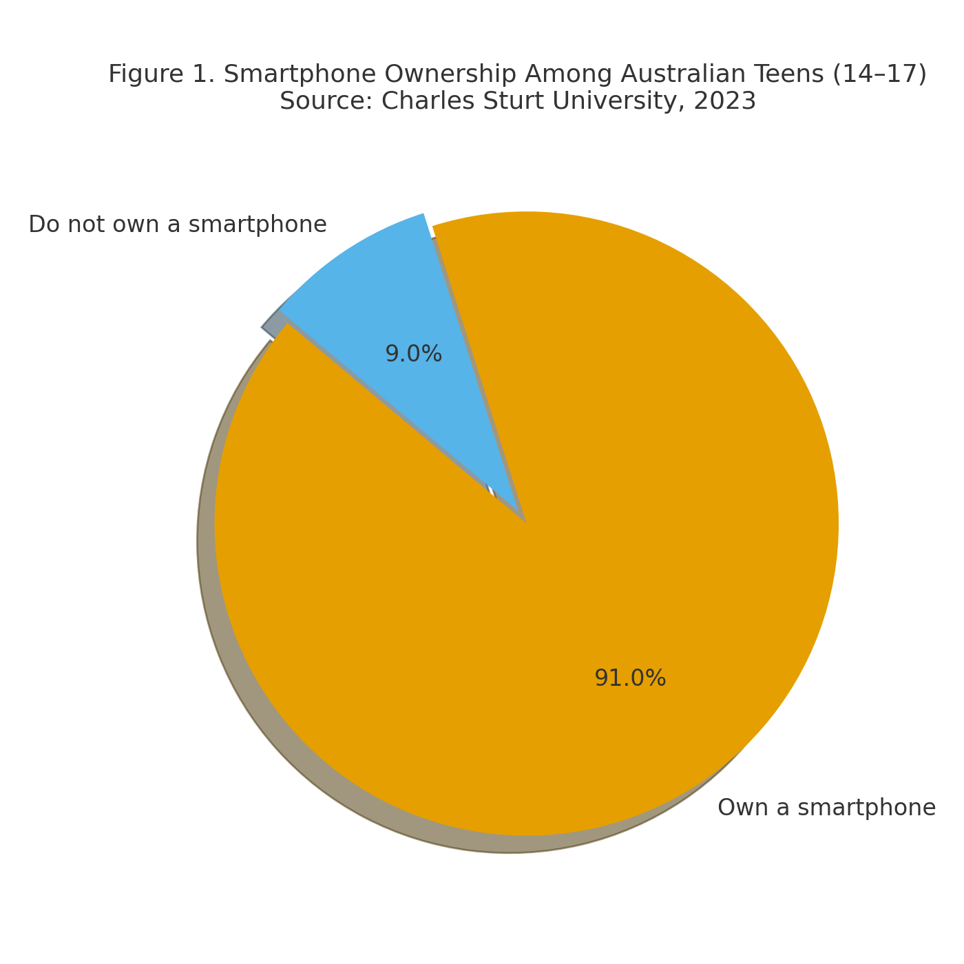

### Mental Health Effects

Research links heavy smartphone use with **poor sleep, stress, anxiety, depression, and mood instability**. An Australian cohort study reported significantly higher distress among “high-severe” users than moderate users (Khan et al., 2023). Another Australian study found that **smartphone distraction and compulsive checking predicted higher anxiety and depression**, reinforcing the link between overuse and mental health difficulties (VU study PDF: [https://vuir.vu.edu.au/40507/12/SmartphoneArticleFinalVersion.pdf](https://vuir.vu.edu.au/40507/12/SmartphoneArticleFinalVersion.pdf?utm_source=chatgpt.com)).

For teenagers, the patterns are stronger. **Sleep** is a core pathway: blue light delays melatonin, and late-night scrolling reduces total sleep time and sleep quality. The **Black Dog Institute (2024)** reported that teens with **high screen time** had more sleep difficulties and higher rates of depressive symptoms; after-midnight use was a particular risk (PDF: [https://www.blackdoginstitute.org.au/wp-content/uploads/2024/08/Teens-Screens_Report-2024_WEB.pdf](https://www.blackdoginstitute.org.au/wp-content/uploads/2024/08/Teens-Screens_Report-2024_WEB.pdf?utm_source=chatgpt.com)). Social comparison on curated feeds can lower self-esteem, while **cyberbullying** extends school stress into home hours, keeping teens emotionally “on-call.”

### Economic Costs

Smartphones add major value to Australia’s economy. **Deloitte’s Mobile Nation** estimated mobile contributed **AUD $23 billion** in value in 2017–18 and projected **~AUD $65 billion** by 2023 ([https://www.deloitte.com/au/en/services/economics/perspectives/mobile-nation.html](https://www.deloitte.com/au/en/services/economics/perspectives/mobile-nation.html?utm_source=chatgpt.com)). But overuse creates **hidden costs**: distraction and “presenteeism” (physically present but mentally elsewhere) reduce output. Lab and field studies show **notifications and alerts disrupt attention and increase errors**; even small pings can slow task completion (Upshaw et al., 2022: [https://journals.plos.org/plosone/article?id=10.1371/journal.pone.0277220](https://journals.plos.org/plosone/article?id=10.1371%2Fjournal.pone.0277220&utm_source=chatgpt.com)).

There are also **health-system costs**. The Australian Institute of Health and Welfare reported **AUD $8.1 billion** spent on specialised mental-health services in 2022–23 (AIHW: [https://www.aihw.gov.au/mental-health/topic-areas/expenditure](https://www.aihw.gov.au/mental-health/topic-areas/expenditure?utm_source=chatgpt.com)). While not all of this is due to smartphones, research suggests that problematic use worsens sleep and mood, which likely **raises demand** for services. For students, reduced focus can lower grades and future earnings; for adults, errors and slower work add up across the economy.

#### Figure 2. Australian mobile industry economic contribution Source: Deloitte Mobile Nation (2018 & 2023)

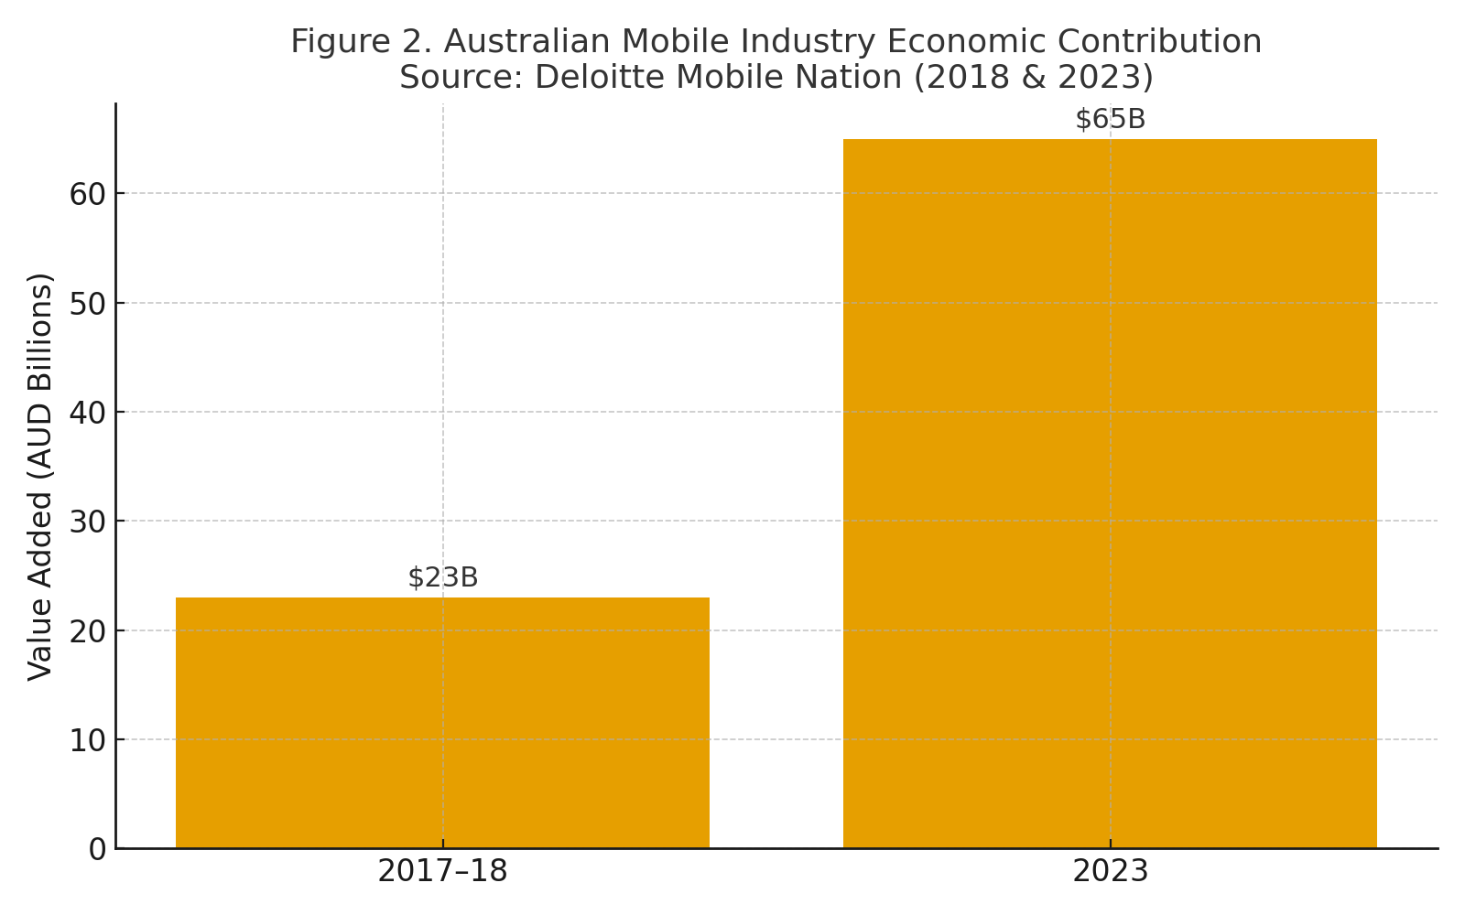

### Security and Privacy Risks

A 2023 CSU commentary warned that many teen phones and accounts remain **public or loosely protected**, exposing **location and identity data** (CSU link above). Addiction-like habits make risky behaviours more likely: **clicking unknown links**, **installing unvetted apps**, **oversharing**, and **re-using weak passwords**. Nationally, Australians lost **record amounts to scams** in recent years (e.g., ACCC reports on SMS phishing and fake shopping sites); teens are increasingly targeted via social media and messaging. These behaviours connect the **human factors** of overuse (impulsivity, fatigue, split attention) with **technical exposure** (open profiles, permissive app permissions), raising the probability of compromise.

#### Figure 3. Mental health expenditure by states/territories (2022–23) Source: Australian Institute of Health and Welfare (AIHW)

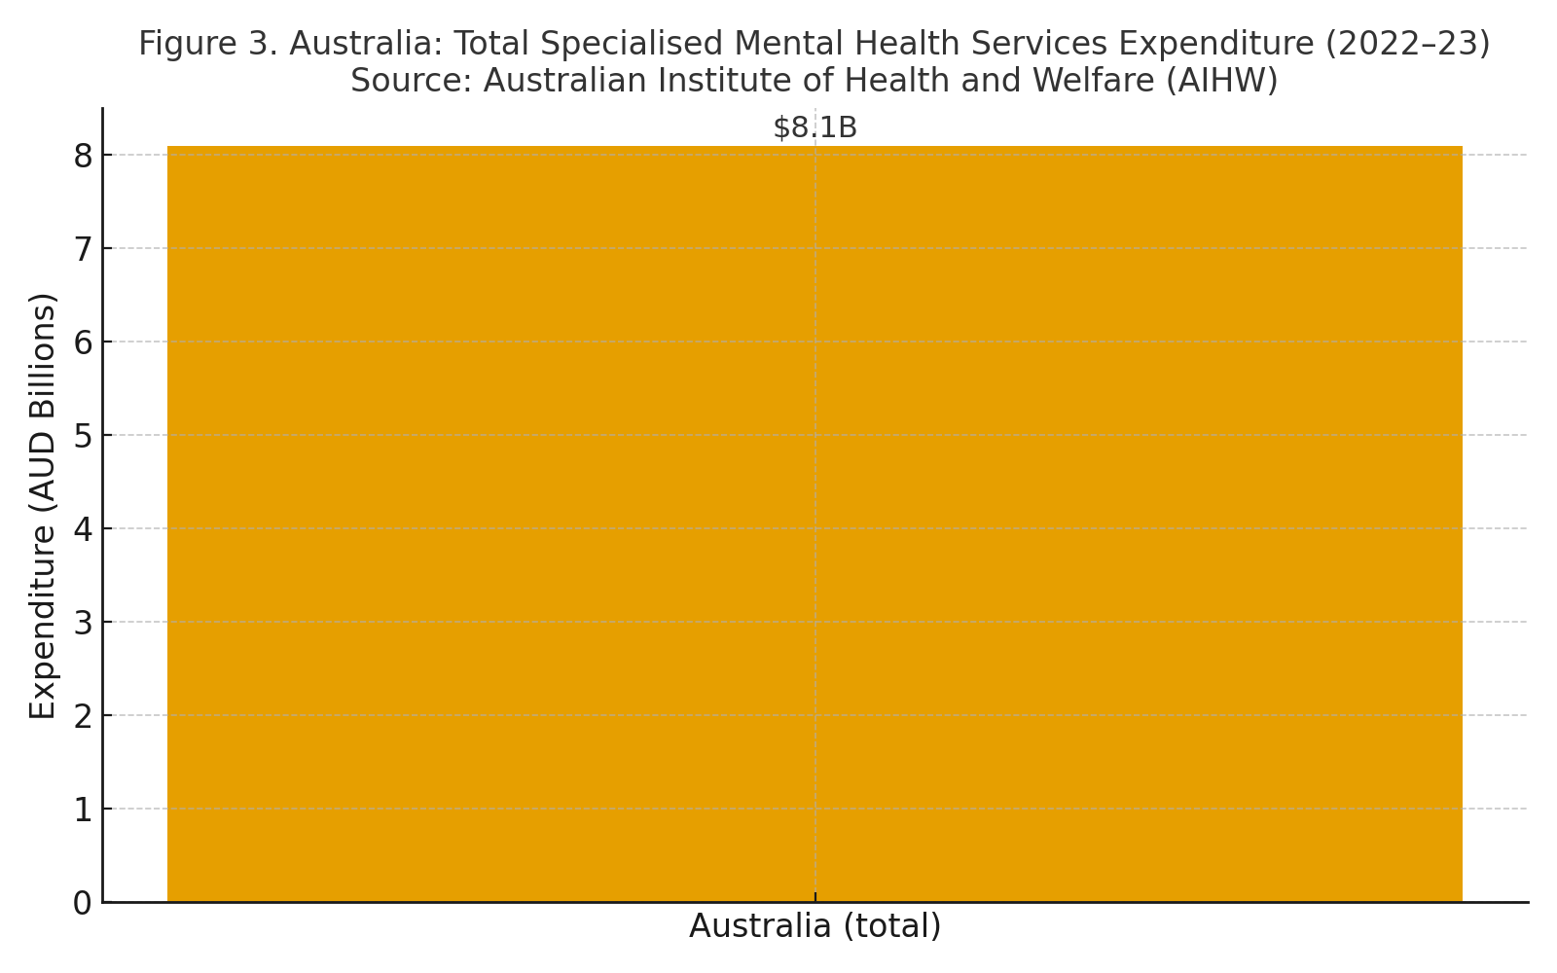

## Section III: Literature Review (6 recent sources)

### 1) Black Dog Institute (2024) – Australian teens, screens, and mental health

This national report links **high daily screen time** with **sleep problems, anxiety, and depressive symptoms** in Australian teenagers. It flags **after-midnight phone use** as a key risk for next-day tiredness and mood issues. Recommendations include **school-based digital wellbeing** and **parental guidance** that limits late-night use and promotes balanced routines.  
PDF: [https://www.blackdoginstitute.org.au/wp-content/uploads/2024/08/Teens-Screens_Report-2024_WEB.pdf](https://www.blackdoginstitute.org.au/wp-content/uploads/2024/08/Teens-Screens_Report-2024_WEB.pdf?utm_source=chatgpt.com)

### 2) Kabadayi et al. (2024) – Adolescents’ smartphone addiction & mental health

A **BMC Psychology** study of **13–18-year-olds** found strong associations between **smartphone addiction** and **depression, anxiety/stress, loneliness, and reduced sleep quality**. The authors note that constant online presence amplifies **peer pressure** and crowds out **in-person interaction**. They suggest **family/school supports**, **outdoor activity**, and **late-night limits** as practical steps.  
Article: [https://bmcpsychology.biomedcentral.com/articles/10.1186/s40359-024-02117-6](https://bmcpsychology.biomedcentral.com/articles/10.1186/s40359-024-02117-6?utm_source=chatgpt.com)

### 3) Marshall et al. (2025) – Australian children/teens: overuse and social development

In **Current Psychology**, Marshall and colleagues report that excessive smartphone and gaming use correlates with **poorer social skills** and **higher risk of internet gaming disorder** among Australian youth. A key message is **early intervention**: patterns formed in adolescence tend to **persist into adulthood**, so **school programs** and **family routines** are most effective when introduced early.  
Springer: [https://link.springer.com/article/10.1007/s12144-025-07975-w](https://link.springer.com/article/10.1007/s12144-025-07975-w?utm_source=chatgpt.com)

### 4) Allcott, Gentzkow, & Song (2022) – Economic view of digital addiction

This **American Economic Review** paper models how **digital addiction** reduces **productivity** and **self-control**. In experiments and observational data, heavier users show **lower task performance** and **difficulty sticking to limits**. The authors support **“nudges”** (timers, reminders, friction for endless scroll) and **policy guardrails** to reduce the most addictive design patterns.  
AER: [https://www.aeaweb.org/articles?id=10.1257/aer.20210867](https://www.aeaweb.org/articles?id=10.1257%2Faer.20210867&utm_source=chatgpt.com)

### 5) Upshaw et al. (2022) – Notifications degrade attention and accuracy

In **PLOS ONE**, simple notification pings were shown to **break focus**, increasing **task errors** and **time to completion**. The result generalises to classrooms, offices, and safety-critical settings (e.g., driving): the more frequent the interruptions, the **weaker the cognitive control**. Practical fixes include **notification batching**, **focus modes**, and **scheduled “quiet hours.”**  
PLOS: [https://journals.plos.org/plosone/article?id=10.1371/journal.pone.0277220](https://journals.plos.org/plosone/article?id=10.1371%2Fjournal.pone.0277220&utm_source=chatgpt.com)

### 6) Zhu et al. (2025) – Addiction, negative emotions, and life satisfaction

A **Frontiers in Psychiatry** study found that higher smartphone addiction scores were associated with **more negative emotions** and **lower life satisfaction**. The authors encourage **digital wellbeing tools**, **awareness campaigns**, and **habit-building routines** (e.g., phone-free time blocks) to shift daily patterns.  
Frontiers: [https://www.frontiersin.org/journals/psychiatry/articles/10.3389/fpsyt.2025.1542040/full](https://www.frontiersin.org/journals/psychiatry/articles/10.3389/fpsyt.2025.1542040/full?utm_source=chatgpt.com)

## Section IV: Gaps, Observations, and Recommendations

### Gaps (what the evidence still misses)

* **Economic costing in Australia:** We lack precise **dollar estimates** of productivity loss tied specifically to teen and adult overuse.
* **Security-focused studies:** Compared to mental health, **privacy & cyber-risk** among addicted teens is **under-researched**.
* **Age-specific solutions:** Many studies group teens and adults, but **teen mechanisms** (peer pressure, night-time use, social comparison) call for **targeted interventions**.
* **Long-term effectiveness:** We need trials that measure whether **wellbeing apps, school modules, and policy nudges** keep working beyond the first months.

### Recommendations (multi-level, practical)

**Schools**

* Add **digital wellbeing** to the health curriculum: sleep hygiene, focus strategies, and “what to do when I can’t stop scrolling.”
* Build **phone-aware class rules** (e.g., device caddies during lessons, scheduled phone breaks).
* Teach **cyber-safety basics**: privacy settings, phishing red flags, trusted downloads.

**Families**

* Model balanced habits: **no phones at meals**, **charging outside bedrooms**, **evening wind-down** without screens.
* Use **shared agreements**: set gentle time limits, turn on **Focus/Do-Not-Disturb** for homework and sleep.
* Encourage **offline activities** (sport, clubs, music) to widen sources of reward beyond screens.

**Health services**

* Train school counsellors and GPs to screen for **sleep issues and anxiety** tied to overuse.
* Offer brief **behavioural programs** focused on habit change (e.g., week-long challenges, monitoring & feedback).

**Technology companies**

* Make **safety and balance** the default: clear **usage dashboards**, **break prompts**, and **easy Focus modes**.
* Reduce **addictive patterns** (infinite scroll, autoplay) for teen accounts or allow **opt-out by default**.
* Strengthen **privacy defaults** on new teen devices/accounts.

**Government and policy**

* Run **public awareness** on sleep, mental health, and phishing risks.
* Issue **design guidance** for youth-facing apps; consider **codes of practice** for persuasive design.
* Support **independent research** to quantify costs and test what works at scale.

**Future research**

* Build **Australian cost models** that link screen-time distributions to output, education, and health expenditure.
* Conduct **longitudinal trials** of school and family interventions (6–24 months) with mental-health and security outcomes.

## Section V: Conclusion

Smartphones are here to stay—and for good reason. They connect teens to friends, ideas, and opportunities. But when use becomes **hard to control**, the downsides grow: **worse sleep and mood, lower focus and grades, higher anxiety and depression, and more exposure to scams and data leaks**. For Australia, these personal harms become public concerns: **lost productivity**, **greater health costs**, and **cyber-safety risks** that affect families and schools.

The evidence shows real and fixable pathways. Sleep is improved by **evening limits** and **phone-free bedrooms**. Focus grows when **notifications are batched** and **Focus modes** are routine. Security improves when **privacy defaults are stronger** and teens learn to spot **phishing** and **permissions traps**. Schools can teach these skills; families can model them; health services can support habit change; and technology companies can design for **wellbeing first**—especially for young accounts. Government can help by setting expectations for safer defaults and funding research that measures costs and tests solutions over time.

The aim is **balance**. We do not need to remove smartphones from teenage life; we need to **shape** their use so the **benefits remain** and the **harms shrink**. If Australia takes coordinated steps now—across classrooms, households, clinics, platforms, and policy—we can protect teen mental health, reduce hidden economic losses, and build safer digital habits for the next generation.

## References

* Allcott, H., Gentzkow, M., & Song, L. (2022). Digital addiction. *American Economic Review, 112*(7), 2273–2311. [https://www.aeaweb.org/articles?id=10.1257/aer.20210867](https://www.aeaweb.org/articles?id=10.1257%2Faer.20210867&utm_source=chatgpt.com)
* Australian Institute of Health and Welfare. (2023). *Mental health services expenditure*. [https://www.aihw.gov.au/mental-health/topic-areas/expenditure](https://www.aihw.gov.au/mental-health/topic-areas/expenditure?utm_source=chatgpt.com)
* Black Dog Institute. (2024). *Teens & Screens: Mental health impacts of digital use*. [https://www.blackdoginstitute.org.au/wp-content/uploads/2024/08/Teens-Screens_Report-2024_WEB.pdf](https://www.blackdoginstitute.org.au/wp-content/uploads/2024/08/Teens-Screens_Report-2024_WEB.pdf?utm_source=chatgpt.com)
* Charles Sturt University. (2023). *91% of Australian teens have a phone — but many are not secure*. [https://news.csu.edu.au/opinion/91-per-cent-of-australian-teens-have-a-phone-but-many-are-not-secure](https://news.csu.edu.au/opinion/91-per-cent-of-australian-teens-have-a-phone-but-many-are-not-secure?utm_source=chatgpt.com)
* Deloitte. (2019). *Mobile Nation: The economic and social impacts of mobile technology in Australia*. [https://www.deloitte.com/au/en/services/economics/perspectives/mobile-nation.html](https://www.deloitte.com/au/en/services/economics/perspectives/mobile-nation.html?utm_source=chatgpt.com)
* Kabadayi, E., Gunes, E., & Ulas, O. (2024). Smartphone addiction, depression, distress, eustress, loneliness, and sleep deprivation in adolescents. *BMC Psychology, 12*(1), 1–13. [https://bmcpsychology.biomedcentral.com/articles/10.1186/s40359-024-02117-6](https://bmcpsychology.biomedcentral.com/articles/10.1186/s40359-024-02117-6?utm_source=chatgpt.com)
* Khan, A., Uddin, R., et al. (2023). Excessive smartphone use and mental health outcomes among Australian adults. *Journal of Medical Internet Research*. [https://link.springer.com/article/10.1007/s10916-023-02005-3](https://link.springer.com/article/10.1007/s10916-023-02005-3?utm_source=chatgpt.com)
* Marshall, K., Warburton, W., Kangas, M., & Sweller, N. (2025). Problematic smartphone and gaming use among Australian children and adolescents. *Current Psychology*. [https://link.springer.com/article/10.1007/s12144-025-07975-w](https://link.springer.com/article/10.1007/s12144-025-07975-w?utm_source=chatgpt.com)
* Upshaw, J. B., Stevens, M., Ganis, G., & Zabelina, D. (2022). The hidden cost of a smartphone: Effects of notifications on cognitive control. *PLOS ONE, 17*(11), e0277220. [https://journals.plos.org/plosone/article?id=10.1371/journal.pone.0277220](https://journals.plos.org/plosone/article?id=10.1371%2Fjournal.pone.0277220&utm_source=chatgpt.com)
* Zhu, Y., Li, S., & Zhang, L. (2025). Smartphone addiction, negative emotions, and life satisfaction: A moderated-mediation model. *Frontiers in Psychiatry, 16*, 1542040. [https://www.frontiersin.org/journals/psychiatry/articles/10.3389/fpsyt.2025.1542040/full](https://www.frontiersin.org/journals/psychiatry/articles/10.3389/fpsyt.2025.1542040/full?utm_source=chatgpt.com)

## AI Acknowledgement Statement (for your SIT325 submission)

I used generative AI (ChatGPT – GPT-5) to help plan, structure, and draft sections of this research report. Specifically, I used it to:

* Organise the report into the required sections (Abstract, Introduction, Problem with Evidence, Literature Review, Gaps/Recommendations, Conclusion).
* Suggest relevant peer-reviewed sources and provide links to original studies.
* Assist in generating draft figures (graphs and charts) using data from official reports (e.g., AIHW, Deloitte, CSU).
* Expand and refine wording to improve clarity, flow, and readability.

I then critically reviewed, fact-checked, and edited the content to ensure accuracy, originality, and alignment with the unit requirements. I take full responsibility for the final submission, and all sources referenced are genuine, with working links included in the References section.